**BANK LOAN REPORT QUERY DOCUMENT**

1. **BANK LOAN REPORT | SUMMARY**

**KPI’s:**

**Total Loan Applications**

select count(id) as Total_Loan_Applications from bank_loan_data  
  
  
**MTD Loan Applications**

select count(id) as MTD_Total_Loan_Applications from bank_loan_data

where month(issue_date) = 12 and year(issue_date) = 2021  


**PMTD Loan Applications**

select count(id) as PMTD_Total_Loan_Applications from bank_loan_data

where month(issue_date) = 11 and year(issue_date) = 2021  


**Total Funded Amount**

select SUM(loan_amount) as Total_Funded_Amount FROM bank_loan_data  


**MTD Total Funded Amount**

select SUM(loan_amount) as MTD_Total_Funded_Amount FROM bank_loan_data

where month(issue_date) = 12 and year(issue_date) = 2021  
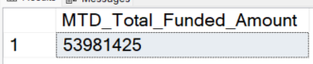

**PMTD Total Funded Amount**

select SUM(loan_amount) as PMTD_Total_Funded_Amount FROM bank_loan_data

where month(issue_date) = 11 and year(issue_date) = 2021  


**Total Amount Received**

select sum(total_payment) as Total_Amount_received FROM bank_loan_data  


**MTD Total Amount Received**

select sum(total_payment) as MTD_Total_Amount_received FROM bank_loan_data

where month(issue_date) = 12 and year(issue_date) = 2021  


**PMTD Total Amount Received**

select sum(total_payment) as PMTD_Total_Amount_received FROM bank_loan_data

where month(issue_date) = 11 and year(issue_date) = 2021  


**Average Interest Rate**

select ROUND(avg(int_rate),4)*100 as MTD_Avg_Interest_Rate From bank_loan_data  


**MTD Average Interest**

select ROUND(avg(int_rate),4)*100 as MTD_Avg_Interest_Rate From bank_loan_data

WHERE MONTH(ISSUE_DATE) = 12 AND YEAR(ISSUE_DATE) = 2021  


**PMTD Average Interest**

select ROUND(avg(int_rate),4)*100 as PMTD_Avg_Interest_Rate From bank_loan_data

WHERE MONTH(ISSUE_DATE) = 11 AND YEAR(ISSUE_DATE) = 2021  


**Avg DTI**

select ROUND(avg(dti),4)*100 as Avg_DTI From bank_loan_data  


**MTD Avg DTI**

select ROUND(avg(dti),4)*100 as MTD_Avg_DTI From bank_loan_data

WHERE MONTH(ISSUE_DATE) = 12 AND YEAR(ISSUE_DATE) = 2021  
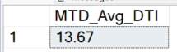

**PMTD Avg DTI**

select ROUND(avg(dti),4)*100 as PMTD_Avg_DTI From bank_loan_data

WHERE MONTH(ISSUE_DATE) = 11 AND YEAR(ISSUE_DATE) = 2021  


**GOOD LOAN ISSUED**

**Good Loan Percentage**

SELECT

(COUNT(CASE WHEN loan_status = 'Fully Paid' OR loan_status= 'Current'

THEN id END)*100)/ COUNT(id) as Good_loan_percentage

from bank_loan_data  


**Good Loan Applications**

SELECT COUNT(id) as Good_Loan_Applications FROM bank_loan_data

WHERE loan_status = 'Fully Paid' OR loan_status ='Current'  


**Good Loan Funded Amount**

SELECT SUM(loan_amount) as Good_Loan_Funded_Amount FROM bank_loan_data

WHERE loan_status = 'Fully Paid' OR loan_status ='Current'  


**Good Loan Amount Received**

SELECT SUM(total_payment) as Good_Loan_Recieved_Amount FROM bank_loan_data

WHERE loan_status = 'Fully Paid' OR loan_status ='Current'  
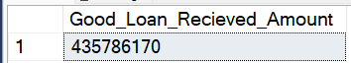

**BAD LOAN ISSUED**

**Bad Loan Percentage**

SELECT

(COUNT(CASE WHEN loan_status = 'Charged Off'

THEN id END)*100)/ COUNT(id) as Bad_loan_percentage

from bank_loan_data  


**Bad Loan Applications**

SELECT COUNT(id) as Bad_Loan_Applications FROM bank_loan_data

WHERE loan_status = 'Charged Off'  


**Bad Loan Funded Amount**

SELECT SUM(loan_amount) as Bad_Loan_Funded_Amount FROM bank_loan_data

WHERE loan_status = 'Charged Off'  


**Bad Loan Amount Received**

SELECT SUM(total_payment) as Bad_Loan_Recieved_Amount FROM bank_loan_data

WHERE loan_status = 'Charged Off'  


**LOAN STATUS**

SELECT

loan_status,

COUNT(id) AS Total_Loan_Applications,

SUM(total_payment) AS Total_Amount_Received,

SUM(loan_amount) AS Total_Funded_Amount,

AVG(int_rate * 100) AS Interest_Rate,

AVG(dti * 100) AS DTI

FROM

bank_loan_data

GROUP BY

loan_status  


SELECT

loan_status,

SUM(total_payment) AS MTD_Total_Amount_Received,

SUM(loan_amount) AS MTD_Total_Funded_Amount

FROM bank_loan_data

WHERE MONTH(issue_date) = 12

GROUP BY loan_status

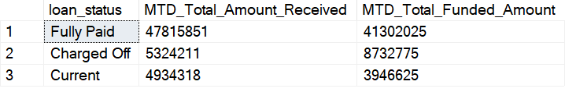

1. **BANK LOAN REPORT | OVERVIEW**

**MONTH**

SELECT

MONTH(issue_date) AS Month_Munber,

DATENAME(MONTH, issue_date) AS Month_name,

COUNT(id) AS Total_Loan_Applications,

SUM(loan_amount) AS Total_Funded_Amount,

SUM(total_payment) AS Total_Amount_Received

FROM bank_loan_data

GROUP BY MONTH(issue_date), DATENAME(MONTH, issue_date)

ORDER BY MONTH(issue_date)  
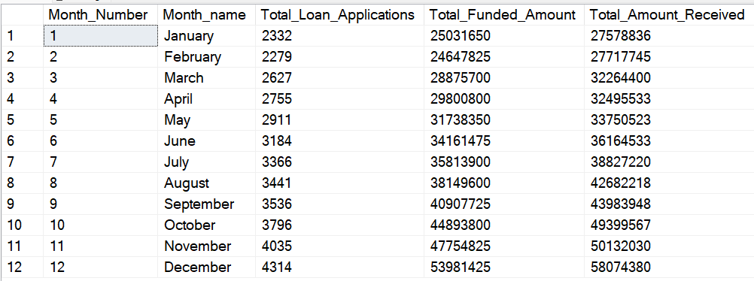

**STATE**

SELECT

address_state AS State,

COUNT(id) AS Total_Loan_Applications,

SUM(loan_amount) AS Total_Funded_Amount,

SUM(total_payment) AS Total_Amount_Received

FROM bank_loan_data

GROUP BY address_state

ORDER BY address_state

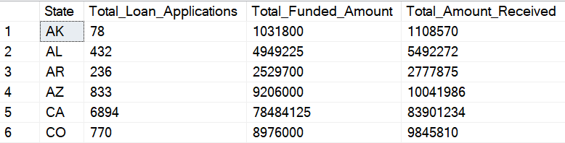

**TERM**

SELECT

term AS Term,

COUNT(id) AS Total_Loan_Applications,

SUM(loan_amount) AS Total_Funded_Amount,

SUM(total_payment) AS Total_Amount_Received

FROM bank_loan_data

GROUP BY term

ORDER BY term  
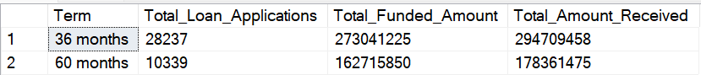

**EMPLOYEE LENGTH**

SELECT

emp_length AS Employee_Length,

COUNT(id) AS Total_Loan_Applications,

SUM(loan_amount) AS Total_Funded_Amount,

SUM(total_payment) AS Total_Amount_Received

FROM bank_loan_data

GROUP BY emp_length

ORDER BY emp_length  
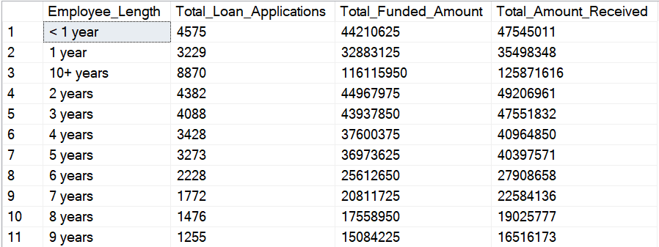

**PURPOSE**

SELECT

purpose AS PURPOSE,

COUNT(id) AS Total_Loan_Applications,

SUM(loan_amount) AS Total_Funded_Amount,

SUM(total_payment) AS Total_Amount_Received

FROM bank_loan_data

GROUP BY purpose

ORDER BY purpose  
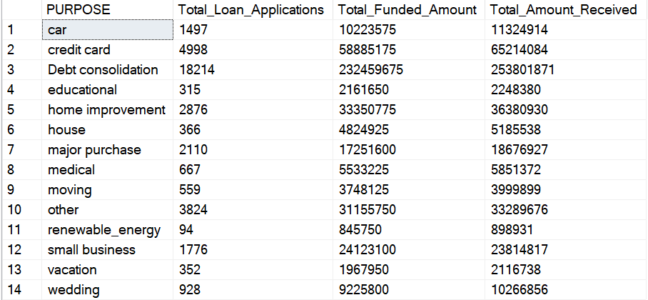

**HOME OWNERSHIP**

SELECT

home_ownership AS Home_Ownership,

COUNT(id) AS Total_Loan_Applications,

SUM(loan_amount) AS Total_Funded_Amount,

SUM(total_payment) AS Total_Amount_Received

FROM bank_loan_data

GROUP BY home_ownership

ORDER BY home_ownership  
